Work plan 2017

In the framework of:

Memorandum of Understanding
for the Management of the Extended Transboundary Drin Basin

GEF Project “Enabling Transboundary Cooperation and Integrated Water Resources Management in the Extended Drin River Basin”

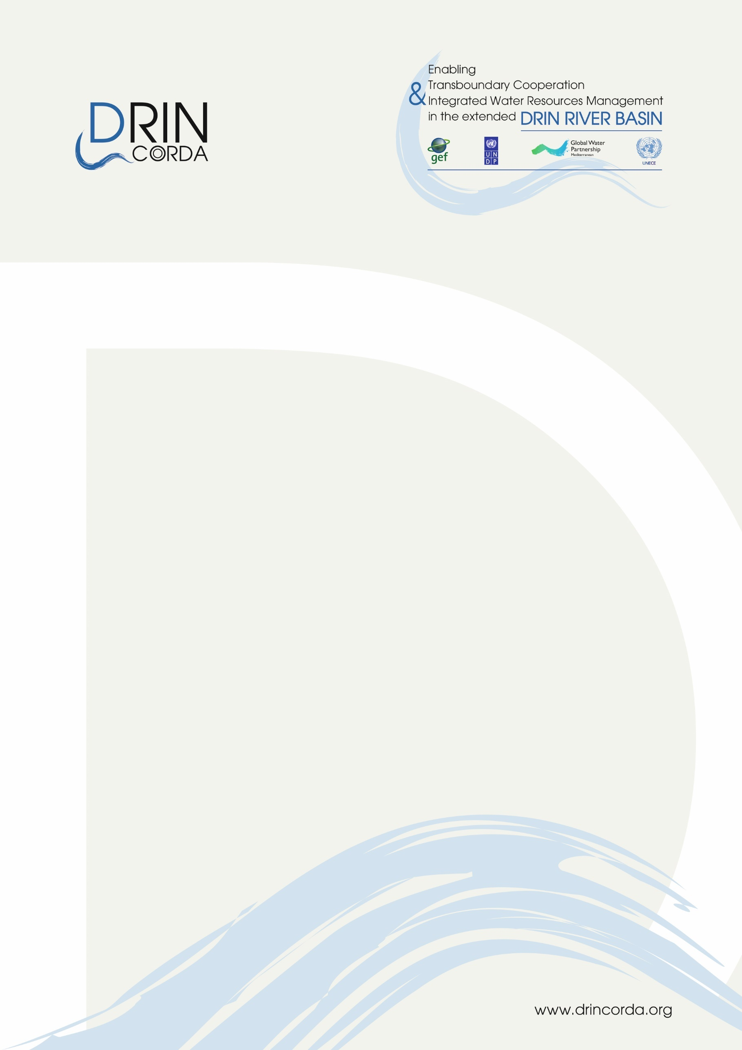

The Coordinated Action for the implementation of the Memorandum of Understanding for the management of the Drin basin (Drin CORDA) is supported by the GEF Drin Project. The latter is implemented by the United Nations Development Programme (UNDP) and executed by the Global Water Partnership (GWP) through GWP-Mediterranean (GWP-Med), in cooperation with the United Nations Economic Commission for Europe (UNECE). GWP-Med serves as the Secretariat of the Drin Core Group, the multilateral body responsible for the implementation of the Memorandum of Understanding.

Disclaimer: The document adheres to the UN rules and policies regarding the names and international status of countries and/or other geographical areas etc. The use of characterizations, names, maps or other geographical statements in this document in no way implies any political view or positions of the Parties which are executing and implementing the Project.

For more information, please contact

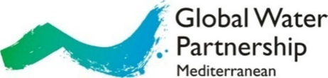

Web: www.gwpmed.org

Headquarters:
12, Kyrristou str., 10556
Athens, Greece
T: +30210-3247490, -3247267, F: +30210-3317127

Work plan January – December 2017

# | Actions | Activities / Steps | Months
COMPONENT 1. CONSOLIDATING A COMMON KNOWLEDGE BASE

OUTCOME 1: CONSENSUS AMONG COUNTRIES ON KEY TRANSBOUNDARY CONCERNS, INCLUDING CLIMATE CHANGE AND VARIABILITY, REACHED THROUGH JOINT FACT FINDING
Output 1. Transboundary Diagnostic Analysis (TDA)
 | Overall | - Coordination and provision of technical guidance to officers and consultants, preparation and editing of technical reports, assurance of quality of outputs, coordination with institutions in beneficiary countries and territories  - Coordination of and provision of technical support for the stakeholders’ consultation process | 1-12
 | Development of the Transboundary Diagnostic Analysis (TDA) report | - Information and Data collection/generation  - Collection of data from institutions that generate or manage these and feed in Database and GIS  - Sampling (chemical and biological) and analysis of samples  - Interpretation of samples’ analysis data and preparation of related report  - Working with a hydrological model for preparation of water budget in the basin.  - Development of groundwater module for the hydrological model that has been prepared through a GIZ project  - Runs of the hydrological model and preparation of a model outputs technical report  - Preparation of Thematic reports on:  - Pollution  - Institutional and Legal Setting  - Biodiversity and Ecosystems  - Socioeconomics  - Hydrology/Hydrogeology  - Water-Food-Energy-Ecosystems Nexus  - Preparation of TDA Synthesis Report | 1-12  1-5  6-7  1-6  1-9  7-9  7-9  1-7  1-7  1-9  7-9  10-11
 | Consultation with the stakeholders | - Organization of 1 Stakeholders Conference at transboundary level on the draft TDA P (operationally linked and contributing to the on Outcome 2 / Output 4 related to the Shared Vision and Output 5 related to the SAP)  - Logistical arrangements including travel, accommodation, meals of participants, technical issues including venue, interpretation, reproduction of material etc.  - Organization of web-based consultation process and provision of comments | 9-10  11-12  7-11
Output 2. Drivers of Change and Indicators
 | No action in 2017
Output 3. Information Management System (IMS)
 | Overall | - Coordination and provision of technical guidance to company, assurance of quality of outputs, coordination with institutions in beneficiary countries and territories | 1-12
 | Development of the IMS | - Preparation of draft ToR and specifications for the development of the IMS by the contracted company  - Presentation of the draft ToR and specifications to EWGs and approval by EWGs  - Incorporation of comments and preparation of final ToR and Specifications  - Procurement and contracting  - Preparation of call of Interest  - Evaluation of offers  - Selection and contracting of consultant  - Work for creating the IMS, initiates and develops | 1-6  6-7  7-9  10-12
COMPONENT 2. Building the foundation for multi-country cooperation
OUTCOME 2: VISIONING PROCESS OPENS THE WAY FOR SYSTEMATIC COOPERATION IN THE MANAGEMENT OF THE TRANSBOUNDARY DRIN RIVER BASIN
Output 4. Shared Vision
Output 5. Strategic Action Program (SAP) with a 5 years’ time horizon and consistent with the Shared Vision formulated
 | Development of an agreed process for the development and adoption of the SAP | - Preparation of a draft Strategy for the development of the SAP and a Concept Paper outlining the framework of action, the steps to be followed and the process for official discussions and negotiations for its adoption  - The draft Strategy/Concept Paper is presented to the EWGs and the DCG  - Incorporation of comments  - Discussion in the DCG and adoption of the document | 4-5  6  7  12
OUTCOME 3: COUNTRIES AND DONORS COMMIT TO SUSTAIN JOINT COOPERATION MECHANISMS AND TO UNDERTAKE PRIORITY REFORMS AND INVESTMENTS
Output 6. Partnership Conference
COMPONENT 3. INSTITUTIONAL STRENGTHENING FOR INTEGRATED RIVER BASIN MANAGEMENT (IRBM)

OUTCOME 4: THE OPERATIONALIZATION AND STRENGTHENING OF THE INSTITUTIONAL AND LEGAL FRAMEWORKS FOR TRANSBOUNDARY COOPERATION WILL FACILITATE BALANCING OF WATER USES AND SUSTAINING ENVIRONMENTAL QUALITY THROUGHOUT THE EXTENDED DRIN BASIN
Output 7. High Level Joint Commission for the extended Drin Basin established
 | Support of the work of the DCG and its EWGs | - Day to day support of their operation including (list is not exhaustive):  - Implementation of the decisions of the DCG and EWGs including identifying and mobilising the human and financial resources in this respect  - Provision of technical support including but not restricted to preparation of background documents, concept notes, strategic papers, ToRs etc.  - Communication with and among members of the DCG as well as the members of the EWGs to enable these (DCG and EWG) fulfilling their role as coordinating bodies, and responding to ad-hoc requests in this regard  - Identification of opportunities for deepening and enhancing cooperation and bring these opportunities to the attention of the DCG and Riparians for guidance  - Liaising with the international development community for the identification of opportunities to attract additional support for the implementation of provisions of the Drin MoU that currently not being addressed  - Information provision, awareness raising and strategic communication related to Drin CORDA  - Promoting the Drin CORDA and the project in regional and international fora  - See also under “overall” in the “Actions” column of the 2017 work plan  - Etc. | 1-12
 | Ministerial Meeting | - Organization of one meeting  - Logistical arrangements including travel, accommodation, meals of participants, technical issues including venue, interpretation, reproduction of material etc.  - Provision of technical support including preparation of agenda, background documents and report, facilitating the meeting etc. | Dates to be defined by the DCG meeting of 15 December 2016
 | Drin Core Group Meetings | - Organization of two meetings  - Logistical arrangements including travel, accommodation, meals of participants, technical issues including venue, interpretation, reproduction of material etc.  - Provision of technical support including preparation of agenda, background documents and report, facilitating the meeting etc. | 5-6 and 11-12
 | Expert Working Group Meetings (i) Water Framework Directive, (ii) Expert Working Group Biodiversity, and Ecosystems (iii) Monitoring and Information Exchange | - Organization of two meetings for each EWG  - Logistical arrangements including travel, accommodation, meals of participants, technical issues including venue, interpretation, reproduction of material etc.  - Provision of technical support including preparation of agenda, background documents and report, facilitating the meeting etc. | 5-6 and 11-12
Output 8. Inter-ministerial Committees established and functioning
 | Establishment and operation of Inter-ministerial Committees | - Preparation of ToR for Interministerial committees  - Establishment of Inter-ministerial Committees or usage of existing bodies at the national level as Inter-ministerial Committees for the needs of the Project and the Drin MoU process  - Coordination with DCG members in this regard  - Liaising with ministries and institutions in each Drin Riparian  - Provision technical support to and organization of meetings or participation in meetings (in case of existing bodies)  - Missions at the Riparians  - Preparation of background information material  - Facilitation of the meetings  - Preparation of reports | 1-2  1-6  2-12
Output 10. Training program
 | Capacity Building activities | - Organization of two (2) Capacity Building Workshops  - Preparation of curricula and background documents  - Selection or trainers and participants  - Logistical arrangements including travel, accommodation, meals of participants, technical issues including venue, interpretation, reproduction of material etc.  - Preparation of reports  - Study visit OR Training of research staff in the analysis of samples for the assessment of pollutants.  - Preparation of curricula and background documents  - Selection of trainers and participants  - Logistical arrangements including travel, accommodation, meals of participants, technical issues including venue, interpretation, reproduction of material etc.  - Preparation of reports  - Participation of representatives of the Drin Riparians in regional and international workshops and conferences | 1-6 and 6-12  2 months prior to the event  1 months after the event  5-7  2 months prior to the event  1 months after the event  1-12
COMPONENT 4. DEMONSTRATION OF TECHNOLOGIES AND PRACTICES FOR IWRM AND ECOSYSTEM MANAGEMENT

OUTCOME 5: BENEFITS DEMONSTRATED ON THE GROUND ENVIRONMENTALLY SOUND APPROACHES AND TECHNOLOGIES NEW TO THE REGION
Output 11. A program of on the ground pilot demonstrations will deliver tangible results using quantifiable indicators
 | Overall | Coordination and provision of technical guidance to companies, groups of experts and individual consultants, assurance of quality of outputs, coordination with institutions in beneficiary countries and territories | 1-12
 | Integrated River Basin Management Planning in Lake Ohrid | - Preparation of final ToR  - Incorporation of comments by EWG, preparation of a new version of draft ToR  - Presentation of draft ToR to the institutions the two Ohrid Riparian countries and possibly to the Lake Ohrid Management Committee  - Incorporation of comments and preparation of final ToR  - Procurement and contracting  - Preparation of call of Interest  - Evaluation of offers selection and contracting of consultant(s)  - Establishment of a Steering Committee or use the Lake Ohrid Management Committee in this regard  - Development of the Plan  - Preparation of a work plan by the consultants agreed with Secretariat/PCU and approved by the Steering Committee or the Lake Ohrid Management Committee  - Work initiates and advances | 1-2  1  2  2  3-4  1-4  4-12  4  4-12
 | Wastewater treatment in Shkodra city area | - Preparation of ToR  - Preparation of draft ToR  - Presentation of ToR to the Kosovar institutions  - Incorporation of comments and preparation of final ToR  - Procurement and contracting  - Preparation of call of Interest  - Evaluation of offers, selection and contracting of consultant(s)  - Development of the study  - Preparation of a work plan by the consultants agreed with the Secretariat/PCU  - Work initiates and advances | 1-3  3-4  4-12  4  4-12
 | Wastewater management in Kosovo | - Preparation of ToR  - Preparation of draft ToR  - Presentation of ToR to the Albanian institutions  - Incorporation of comments and preparation of final ToR  - Procurement and contracting  - Preparation of call of Interest  - Evaluation of offers, selection and contracting of consultant(s)  - Development of the study  - Preparation of a work plan by the consultants agreed with the Secretariat/PCU  - Work initiates and advances | 1-3  3-4  4-12  4  4-12
 | Reduction of nutrient load and forest preservation through biomass collection and production of fuel briquettes in Montenegrin part of Skadar Lake | - Preparation of feasibility study for use of biomass for development of briquettes scheme  - Presentation of the outcomes from the FS to the EWG and National institutions  - Preparation of draft ToR and specifications for the development of the biomass collection and production of fuel briquettes scheme  - Preparation of draft ToR and specifications by the contracted company  - Opinion by the EWGs and approval by National Institutions  - Presentation of the draft ToR and specifications to EWGs  - Presentation of the draft ToR National Institutions  - Incorporation of comments  - Preparation of final ToR and Specifications  - Procurement and contracting  - Preparation of call of Interest  - Evaluation of offers, selection and contracting of consultant(s)  - Development of the scheme  - Preparation of a work plan agreed with the Secretariat/PCU  - Work initiates and advances | 1-7  1-6  7  7  8-9  10-12
 | Transboundary Monitoring in Skadar/Shkoder and Buna/Bojana | - Preparation of Concept Note/ToR  - Albania and Montenegro provide comments on the Concept Note/ToR developed by UNESCO  - Incorporation of comments and preparation of final Concept Note/ToR  - UNDP Albania and UNESCO establish and Interagency Agreement having the Concept Note/ToR as an Annex  - Development of the Transboundary Monitoring system in the Skadar/Shkoder and Buna/Bojana areas  - Preparation of a work plan by UNESCO agreed with Albania and Montenegro as well as the Secretariat/PCU  - Work initiates and advances | 1-3  1  1-2  3  4-12  4  4-12
 | Cooperation on Flood Risk Management in the Drin Basin | - Establishment of EWG on Floods  - Preparation of ToR  - Identification of stakeholders to participate in addition to the Ministries participating in the DCG  - Organization of two meetings  - Logistical arrangements including travel, accommodation, meals of participants, technical issues including venue, interpretation, reproduction of material etc.  - Provision of technical support including preparation of agenda, background documents and report, facilitating the meeting etc.  - Preparation of Concept Note/ToR for the pilot activity  - Preparation of draft Concept Note/ToR  - Presentation of the Concept Note/ToR to the EWG  - Incorporation of comments and preparation of final Concept Note/ToR  - Procurement of the study  - Preparation of call of Interest  - Evaluation of offers and preparation of contract  - Initiation of development of the study  - Preparation of a work plan by the consultants agreed with Secretariat/PCU  - Work initiates and advances | 1-2  1-2  1-2  5-6 and 11-12  3-7  3  6  7  7-8  8-12  8  8-12
COMPONENT 5. STAKEHOLDER INVOLVEMENT, GENDER MAINSTREAMING AND COMMUNICATION

OUTCOME 6: PUBLIC SUPPORT AND PARTICIPATION TO IWRM AND JOINT MULTI-COUNTRY MANAGEMENT ENHANCED THROUGH STAKEHOLDER INVOLVEMENT AND GENDER MAINSTREAMING

Output 12. A Stakeholder Involvement and Gender Mainstreaming Strategy defined and implemented
 | Public Participation and Stakeholders Involvement | - Implementation of the Participation and Stakeholders Involvement Strategy  - Stakeholders consultations (including web-based) on issues related to the management of the basin  - Organization of a Stakeholders Conference for the management of the Drin Basin  - Logistical arrangements including travel, accommodation, meals of participants, technical issues including venue, interpretation, reproduction of material etc.  - Provision of technical support including preparation of agenda, background documents and report, facilitating the meeting etc. | 1-12  1-12  10-12
 | Gender Mainstreaming | - Implementation of the Gender Mainstreaming Strategy | 1-12
OUTCOME 7: POLITICAL AWARENESS AT ALL LEVELS AND PRIVATE SECTOR PARTICIPATION STRENGTHENED THROUGH HIGHER VISIBILITY OF THE PROJECT’S DEVELOPMENTS AND TARGETED OUTREACH INITIATIVES.
Output 13. Information, Communication and Outreach Strategy prepared and implemented.
 | Implementation of Communication and Outreach activities | - Communication activities including the following:  - Targeted emails to stakeholders  - Press releases, articles etc.,  - Publicly available summaries of reports, fact sheets  - Organization of awareness raising events  - Celebration of the Drin Day  - Prepare ToR for the celebration of the Drin Day  - Call of interest for NGOs, selection and contracting of NGOs  - Implementation of the Drin Day Celebration Activities  - Strategic communication of the events  - Production and/or reproduction of information and communication material e.g. publications including Leaflets, Brochures, Books, video spots etc. | 1-12  3-6  3  3-4  5  4-6  1-12

